Curriculum Vitae
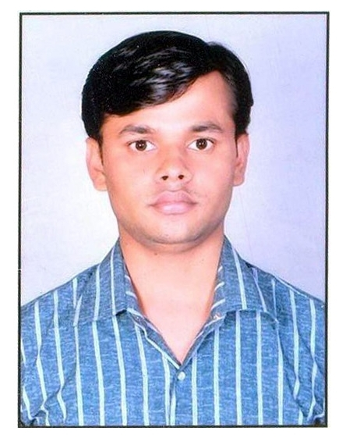
Robins Mathur
H.N. 32 Leela Dhar Colony By Pass
Road Bhopal (M.P.) PIN- 462037
Cont. No. 9074531374
Email id–robinsmathur@gmail.com

Career Objective :-

I shall strive for continuous growth and development of organization with effective team work. Always aim to be creative, innovative and workaholic. To make a carrier with a leading organization contributing towards its growth and personal gain of knowledge.

Personal Skills :-

- Hard working and enthusiastic in learning new things.
- Highly flexible and positive attitude, quick learner.

Education Qualification :-

- Passed MBA (HR& IT) From Affiliated to Dr. CV Raman University Bilaspur (CG).
- Passed Bsc. From Govt. MVM. (PG) College Bhopal, Affiliated to Barkatulla University Bhopal.
- Passed Higher Secondary from JVM High Secondary school Bhopal.
- Passed High school from Elite High Secondary school Bhopal..

Computer Knowledge :-

- (PGDCA)Post Graduation Diploma In Computer Application , Affiliated to Makhanlal Chaturvedi University , Bhopal.
- MS office – word, excel, power point, Internet, e-mail.
- English & Hindi Typing.
Working Experience:-

Organization :- Maharishi Vidhya Mandir ( An Educational Group)
Designation :- Management Trainee
Department :- Personnel & Administration Department
Duration :- 01 Oct 2011 to till date………….
Location :- National Office, Bhopal
Job Profile :- Requirement Process (Short listing Bio-data, Interview calling, Coordinating in Interview) Bio-Metric Attendance Generation, Maintain Leave Record, Made Budget for Schools, Management & B.Ed College, Payroll, SAP, Generation of Employees Salary, Salary Process and employees data base management in PMS software, Appointments, Personal file Management, Office correspondence (Different types of letter, circulars etc.) , Dispatch & Inverts work.

Organization :- Peoples Group (an Educational & Health Care Organization)
Designation :- Computer Operator
Department :- HR Department
Duration :- 13 September 2009 to 05 September 2011
Location :- Bhopal
Job Profile :- Office Correspondence all kinds of Letter (ION, Circulars etc.) or Typing work, Payroll, Bio-Metric Attendance, Maintain Leave Record Housekeeping, Security & Attenders(Peon), Contract and Bill Verification, Company Employees Personal File Maintenance and Updating Personal File Record & Different Unit Correspondence file, Dispatch work (Invert Outward Dak ) etc.

Organization :- LIC EDMS, Bhopal
Designation :- Computer Operator cum Supervisor
Department :- Quality Checking
Duration :- July 2007 to July 2009
Location :- Bhopal
Job Profile :- Computer Operator, Scanning LIC Documents & Quality Check of scanning.

Knowledge & Skills:-

- Telephonic & personally interviewing & screening *Short listing the profiles & arranging for their interviews
*Follow-up/co-ordination with potential candidates & Departments and doing timely closure of positions *Resourcing activities.
- Provide executive level administrative support to the Director and officer.
- Liaise between all impacted departments to ensure proper lines of communications compliance with complex reporting practice.
- Organize the details of special events, travel arrangements, corporate agendas and itinerary.
- Process monthly expense reports, joining report and relieving report reflecting documents and budget code indexes.
- Prepare and maintain monthly attendance, annual vacation and leave record of employees.
- Experience in Administrative function, Security staff, Housekeeping staff and Office staff Management Office accommodation and other administrative work.
- Coordinate with service providers for Housekeeping, Security, Power supply, Repairs and Maintenance of the office premises.
- Responsible for routine office works, providing executive level administrative support to the higher officials. Maintain Inward/Outward Dispatch register, Attendance Register, Office Supplies, Stationery, Inventory Management. Fax, copying, Scanning, Data Entry & Emails communication

Personal Profile :-

Date of Birth :- 24 March 1985
Father’s name :- Shri Dinesh Mathur
Mother’s name :- Smt. Prabha Mathur
Nationality :- Indian
Marital Status :- Married
Language known :- Hindi & English
Parmanent Address :- 32, Leela Dhar Colony By Pass Road Bhanpura Bhopal, PIN – 462037
E-mail Address :- robinsmathur@gmail.com
Contact No :- 9074531374, 9981931353

Declaration

I hereby declare that the above information is true to the best of my knowledge and belief.

Place :- Bhopal ( Robins Mathur)
Date :-

